QBUS3350 – Scope Management

1. Prepare a project scope statement based on the given information.

Earlier in the day you received a fax from the president of Blue Note, Inc. The president wants to reward her top management team by taking them on an all-expense-paid fishing adventure in Alaska. She would like to ask you to organize and lead the expedition. In her fax, she stated “The expedition should take place from 21 to 25 June at a cost no more than US$50,000 and our preferred destination is the Tikchik River system in Alaska. There are two camping sites: Camp I is 10 miles from Dillingham, Alaska and Camp II is 5 miles east to Camp I. The group will first visit camp I and then Camp II. The only airport nearby is at Dillingham.

1. You are a member of the X state University (XSU) student body entertainment committee. Your committee has agreed to sponsor a spring concert. The motive behind this concert is to offer a safe alternative to Hasta Weekend, which is a spring event that students from XSU rent houseboats and engage in heavy partying. Traditionally, this event occurs during the first weekend in October (i.e., south semi-sphere season). Unfortunately, the partying has a long history of getting out of hand, sometimes leading to fatal accidents. After one such tragedy last spring, your committee wants to offer an alternative experience for those who are eager to celebrate the change in weather and the pending end of the semester. You have finished a draft scope statement (see below). You are now brainstorming potential risks associated with the project.
2. Try to come up with 3 potential risks associated with the project.
3. Develop a risk response matrix for each of the risk that you identify.

Project Scope Statement for XSU Spring Concert

Project Objective

To organize and deliver an eight-hour concert at Wahoo Stadium at a cost not to exceed $90,000 on the first Saturday of October.

Deliverables

* Local advertising.
* Concert security.
* Separate beer garden.
* Eight hours of music and entertainment.
* Food venues.
* Souvenir concert t-shirts.
* Secure all licenses and approvals.
* Secure sponsors.

Milestones

1. Secure all permissions and approvals by 15 May.
2. Sign big-name artist by 15 June.
3. Complete artist roster by 1 August.
4. Secure vendor contracts by 30 August.
5. Setup completed 3 October.
6. Concert on 5 October.
7. Clean-up completed by 8 October.

Technical requirements

1. Professional sound stage and system.
2. At least one big-name artist.
3. At least seven performing acts.
4. Restroom facilities for 10,000 people.
5. Parking available for 1000 cars.
6. Compliance with XSU and city regulations / ordinances.

Limits and exclusions

1. Performers responsible for travel arrangements to and from XSU.
2. Vendors contribute 25% of their sales to the concert.
3. Concert must be over by 11:00pm.

Customer Review

The president of XSU student body.

**Project Estimate**

**Question 1:**

Below is a project WBS with cost apportioned by percentages. If the total project cost is estimated to be $600,000, what are the estimated costs for the following deliverables?

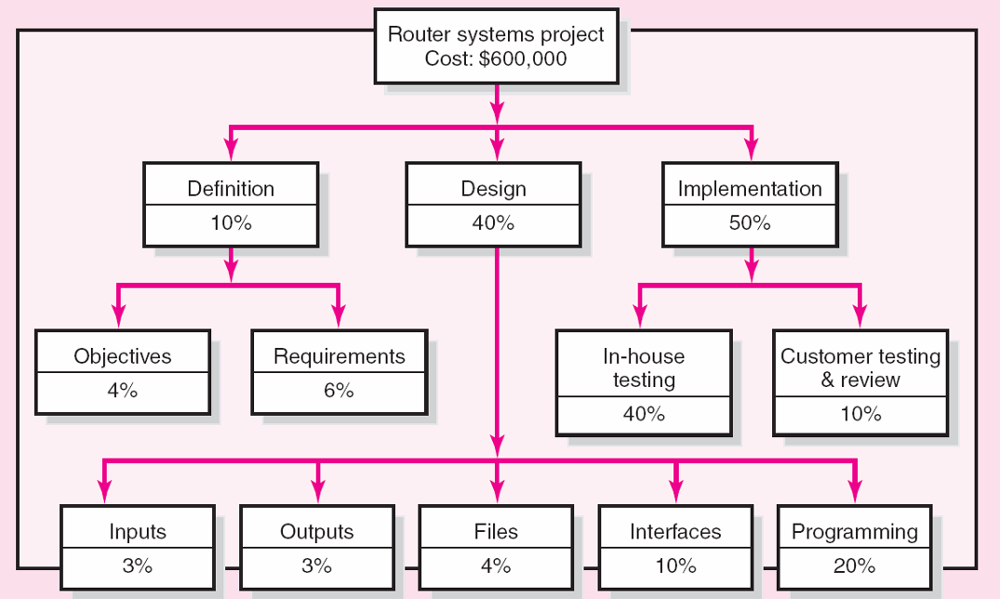

1. Design?
2. Programming?
3. In-house testing?

What weaknesses are inherent in this estimating approach?

**Question 2:**

What are the differences between bottom-up and top-down estimating approaches? Under what conditions would you prefer one over the other?

**Question 3:**

Using the 'complexity weighting' scheme shown in Table 5.2 (refer to lecture slide 21) and the function point complexity weighted table shown below, estimate the total function point count. Assume historical data suggest five function points equal on person-month and six people can work on the project.

|  |  |  |
| --- | --- | --- |
| Complexity weight table | | |
| Number of inputs | 10 | Rated complexity low |
| Number of outputs | 20 | Rated complexity average |
| Number of inquiries | 10 | Rated complexity average |
| Number of files | 30 | Rated complexity high |
| Number of interfaces | 50 | Rated complexity high |

a. What is the estimated project duration?

b. If 20 people are available for the project, what is the estimated project duration?

c. If the project must be completed in six months, how many people will be needed for the project?